

מטלה מספר 1

ניקולאי מלניקוב | 208929653

שם המרצה –ד״ר ליהי רייכלסון

העבודה מוגשת באנגלית במחשבה לשלב אותה בהמשך כפרויקט בעבודה כ -

Security Analyst – Check Point

Cyber Threat Prioritization Agent
- Introduction
In today’s cybersecurity landscape, organizations face an overwhelming number of newly discovered vulnerabilities (CVEs) on a daily basis. Security teams struggle to determine which threats require immediate attention and which can be deprioritized.
The goal of this project is to develop a Cyber Threat Prioritization Agent, a system that analyzes multiple cybersecurity data sources and identifies the most critical threats that should be monitored on a daily basis.
This agent is designed to answer key operational questions such as:
“What is the most important vulnerability or attack I need to pay attention to today?”
“What are the top 3 most common attacks today?”
“What is the most trending attack tool right now?”
“Which attack group has been the most active in the past week?”
These queries reflect real-world security operations needs and guide the design of the agent.
- Problem Definition
Modern security environments are characterized by thousands of new CVEs published each year, limited resources to address all vulnerabilities, and difficulty distinguishing between theoretical risks and real-world threats.
Not all vulnerabilities pose the same level of risk. Some vulnerabilities are already actively exploited, some have publicly available exploit code, and others are low risk or difficult to exploit.
The challenge is to prioritize vulnerabilities based on real-world risk rather than relying only on severity scores.
- Proposed Solution
The proposed solution is an intelligent agent that collects data from multiple cybersecurity sources, combines and enriches vulnerability information, identifies high-risk vulnerabilities, and outputs a prioritized list of threats on a daily basis.
The agent will eventually incorporate risk scoring, contextual threat intelligence, exploit availability, and real-world usage indicators.

- Data Sources
The system relies on four main datasets.
4.1 NVD CVE Dataset
Source: National Vulnerability Database
Format: CSV generated via API
Content includes CVE ID, description, severity, and publication date.
This dataset provides the core list of vulnerabilities to analyze.
4.2 CISA KEV Dataset
Source: CISA
Format: CSV
Content includes CVE IDs known to be actively exploited, vendor information, product, dates, and descriptions.
This dataset identifies vulnerabilities that are already exploited in the wild.
4.3 MITRE ATT&CK Dataset
Source: MITRE ATT&CK
Format: JSON
Content includes attack techniques, tactics, threat groups, and platforms.
This dataset provides contextual understanding of attacker behavior.
4.4 Exploit-DB Dataset
Source: Exploit-DB repository
Format: CSV
Content includes exploit descriptions, publication dates, platforms, and exploit types.
This dataset indicates whether a vulnerability has publicly available exploit code.

- Data Collection
The datasets were collected using Python scripts organized in a structured project.
Project Structure:
Data/
cisa_kev.csv
enterprise-attack.json
exploitdb.csv
latest_20k_cves_from_2026.csv
Scripts/
fetch_cve.py
fetch_kev.py
fetch_mitre_attack.py
fetch_exploitdb_csv.py
Each dataset was downloaded using a dedicated script. CVE data was fetched from the NVD API, KEV was downloaded as a CSV file, MITRE ATT&CK was retrieved as a JSON dataset, and Exploit-DB was downloaded as a CSV file.
- Data Description
This section describes the structure and content of each dataset.
6.1 CVE Dataset
The CVE dataset contains approximately 20,000 recent vulnerabilities. It can be up to 350K but I stopped fetching at 20K because it is a POC
Columns include cve_id, published date, last_modified date, severity, and description.
This dataset is large, structured, and serves as the core for analysis.
6.2 KEV Dataset
The KEV dataset contains vulnerabilities that are known to be actively exploited.
Columns include cveID, vendorProject, product, dateAdded, shortDescription, requiredAction, dueDate, and knownRansomwareCampaignUse.
This dataset is smaller but highly relevant.
6.3 MITRE ATT&CK Dataset
The MITRE dataset is stored as JSON and includes techniques, tactics, threat groups, and software.
It provides behavioral context rather than raw vulnerabilities.
6.4 Exploit-DB Dataset
The Exploit-DB dataset contains exploit information such as id, description, date_published, author, platform, type, and port.
Some entries include references to CVE identifiers.
Summary
The datasets complement each other. CVE provides vulnerabilities, KEV provides exploited vulnerabilities, MITRE provides attack context, and Exploit-DB provides exploit availability.
- Future Work
Future stages of the project will include data integration, feature engineering, risk scoring, and building a daily recommendation engine.
- Conclusion
This project addresses the challenge of prioritizing cybersecurity threats.
By combining multiple data sources and applying structured analysis, the proposed agent will support better decision-making and more efficient security operations.
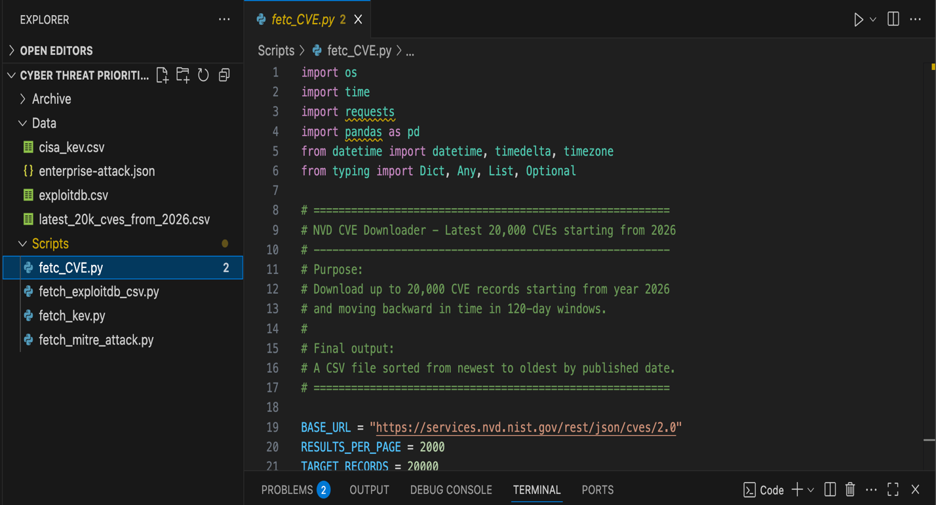
*Adding a screen shot of the project for a reference -

